**Sunny Singh**

**N01390315**

**MainActivity.java**

package com.example.democamera;

import androidx.annotation.Nullable;

import androidx.appcompat.app.AppCompatActivity;

import androidx.core.app.ActivityCompat;

import androidx.core.app.ShareCompat;

import android.Manifest;

import android.app.TimePickerDialog;

import android.content.Intent;

import android.graphics.Bitmap;

import android.graphics.drawable.BitmapDrawable;

import android.net.Uri;

import android.os.Bundle;

import android.os.Environment;

import android.provider.CalendarContract;

import android.provider.MediaStore;

import android.util.Log;

import android.view.View;

import android.widget.Button;

import android.widget.CheckBox;

import android.widget.EditText;

import android.widget.ImageView;

import android.widget.TextView;

import android.widget.TimePicker;

import android.widget.Toast;

import java.io.File;

import java.io.FileOutputStream;

import java.text.SimpleDateFormat;

import java.util.Calendar;

import java.util.Date;

import java.util.TimeZone;

public class MainActivity extends AppCompatActivity {

EditText mShareTextEditText;

private static final int requestCode=15;

private static final int CAMERA_CONSTANT = 156;

Bitmap object;

Button captureImage;

ImageView imgDisplay;

EditText txtEmail,txtTitle,txtStart,txtEnd,txtDescription;

Button submitDate;

CheckBox allDay;

TextView startTime, endTime;

Button btnStart,btnEnd;

long starttimeMilli,endtimeMilli;

private View view,vuew1;

@Override

protected void onCreate(Bundle savedInstanceState) {

super.onCreate(savedInstanceState);

setContentView(R.layout.activity_main);

mShareTextEditText = findViewById(R.id.share_edittext);

imgDisplay =findViewById(R.id.imgCaptured);

ActivityCompat.requestPermissions(MainActivity.this,new String[]{Manifest.permission.WRITE_EXTERNAL_STORAGE},1);

ActivityCompat.requestPermissions(MainActivity.this,new String[]{Manifest.permission.READ_EXTERNAL_STORAGE},1);

txtTitle=findViewById(R.id.txtTitle);

txtEmail=findViewById(R.id.txtEmail);

txtDescription=findViewById(R.id.txtDescription);

Calendar calendar=Calendar.getInstance();

allDay=(CheckBox)findViewById(R.id.checkBoxAllDay);

startTime=findViewById(R.id.txtStartTime);

endTime=findViewById(R.id.txtEndTime);

btnStart=findViewById(R.id.btnStartTime);

btnEnd=findViewById(R.id.btnEndTime);

btnEnd.setOnClickListener(new View.OnClickListener() {

@Override

public void onClick(View v) {

Calendar calendar1=Calendar.getInstance();

int hours=calendar.get(Calendar.HOUR_OF_DAY);

int mins=calendar.get(Calendar.MINUTE);

TimePickerDialog timePickerDialog=new TimePickerDialog(MainActivity.this, R.style.Theme_AppCompat_Dialog_Alert, new TimePickerDialog.OnTimeSetListener() {

@Override

public void onTimeSet(TimePicker view, int hourOfDay, int minute) {

Calendar c=Calendar.getInstance();

c.set(Calendar.HOUR_OF_DAY,hourOfDay);

c.set(Calendar.MINUTE,minute);

c.setTimeZone(TimeZone.getDefault());

SimpleDateFormat format=new SimpleDateFormat("k:mm a");

String time=format.format(c.getTime());

endtimeMilli = c.getTimeInMillis();

endTime.setText(time);

}

},hours,mins,false);

timePickerDialog.show();

}

});

btnStart.setOnClickListener(new View.OnClickListener() {

@Override

public void onClick(View v) {

Calendar calendar1=Calendar.getInstance();

int hours=calendar.get(Calendar.HOUR_OF_DAY);

int mins=calendar.get(Calendar.MINUTE);

TimePickerDialog timePickerDialog=new TimePickerDialog(MainActivity.this, R.style.Theme_AppCompat_Dialog_Alert, new TimePickerDialog.OnTimeSetListener() {

@Override

public void onTimeSet(TimePicker view, int hourOfDay, int minute) {

Calendar c=Calendar.getInstance();

c.set(Calendar.HOUR_OF_DAY,hourOfDay);

c.set(Calendar.MINUTE,minute);

c.setTimeZone(TimeZone.getDefault());

SimpleDateFormat format=new SimpleDateFormat("k:mm a");

String time=format.format(c.getTime());

starttimeMilli = c.getTimeInMillis();

startTime.setText(time);

}

},hours,mins,false);

timePickerDialog.show();

}

});

}

public void captureImage(View view) {

File file = new File(Environment.getExternalStorageDirectory() + "/DCIM/", "image" + new Date().getTime() + ".png");

Uri imgUri = Uri.fromFile(file);

String imgPath = file.getAbsolutePath();

final Intent cameraIntent = new Intent(MediaStore.ACTION_IMAGE_CAPTURE);

startActivityForResult(cameraIntent,CAMERA_CONSTANT);

Toast.makeText(getApplicationContext(),"Save in Storage", Toast.LENGTH_LONG).show();

}

@Override

protected void onActivityResult(int requestCode, int resultCode, @Nullable Intent data) {

super.onActivityResult(requestCode, resultCode, data);

if (requestCode==CAMERA_CONSTANT){

object= (Bitmap) data.getExtras().get("data");

imgDisplay.setImageBitmap(object);

BitmapDrawable bitMapDrawable=(BitmapDrawable)imgDisplay.getDrawable();

Bitmap bitmap=bitMapDrawable.getBitmap();

FileOutputStream outputStream=null;

File file=Environment.getExternalStorageDirectory();

File dir=new File(file.getAbsolutePath()+"/PicturesAndroidClass");

dir.mkdir();

String fileName=String.format("%d.png",System.currentTimeMillis());

File outFile=new File(dir,fileName);

try {

outputStream=new FileOutputStream(outFile);

}catch (Exception e){

e.printStackTrace();

}

bitmap.compress(Bitmap.CompressFormat.PNG,100,outputStream);

try {

outputStream.flush();

}catch (Exception e){

e.printStackTrace();

}

try {

outputStream.close();

}catch (Exception e){

e.printStackTrace();

}

}

}

public void addEvent(View view) {

if (!txtTitle.getText().toString().isEmpty() && !txtDescription.toString().isEmpty() && !txtEmail.toString().isEmpty()) {

Intent intent = new Intent(Intent.ACTION_INSERT);

intent.setData(CalendarContract.Events.CONTENT_URI);

intent.putExtra(CalendarContract.Events.TITLE,txtTitle.getText().toString());

intent.putExtra(Intent.EXTRA_EMAIL,txtEmail.getText().toString());

intent.putExtra(CalendarContract.Events.DESCRIPTION,txtDescription.getText().toString());

if(allDay.isChecked()){

intent.putExtra(CalendarContract.EXTRA_EVENT_ALL_DAY, true);

}

else{

intent.putExtra(CalendarContract.EXTRA_EVENT_BEGIN_TIME, starttimeMilli);

// intent.putExtra(CalendarContract.EXTRA_EVENT_ALL_DAY, false);

}

// int EVENT_BEGIN_TIME_IN_MILLIS = Calendar.getInstance().timeInMillis;

// int EVENT_END_TIME_IN_MILLIS = Calendar.getInstance().add(Calendar.HOUR_OF_DAY, 2).timeInMillis

// val insertCalendarIntent = Intent(Intent.ACTION_INSERT)

// .setData(CalendarContract.Events.CONTENT_URI)

// .putExtra(CalendarContract.Events.TITLE, "TITLE") // Simple title

// .putExtra(CalendarContract.EXTRA_EVENT_ALL_DAY, false)

// .putExtra(CalendarContract.EXTRA_EVENT_BEGIN_TIME,startCalendarInstance) // Only date part is considered when ALL_DAY is true; Same as DTSTART

// .putExtra(CalendarContract.EXTRA_EVENT_END_TIME,endTimeInMillis) // Only date part is considered when ALL_DAY is true

// .putExtra(CalendarContract.Events.EVENT_LOCATION, "Hong Kong")

// .putExtra(CalendarContract.Events.DESCRIPTION, "DESCRIPTION") // Description

// .putExtra(Intent.EXTRA_EMAIL, "fooInviteeOne@gmail.com,fooInviteeTwo@gmail.com")

// .putExtra(CalendarContract.Events.RRULE, getRRule()) // Recurrence rule

// .putExtra(CalendarContract.Events.ACCESS_LEVEL, CalendarContract.Events.ACCESS_PRIVATE)

// .putExtra(CalendarContract.Events.AVAILABILITY, CalendarContract.Events.AVAILABILITY_FREE)

// startActivity(insertCalendarIntent)

if (intent.resolveActivity(getPackageManager()) != null) {

startActivity(intent);

} else

{

Toast.makeText(MainActivity.this, "There is no app that support this action", Toast.LENGTH_SHORT).show();

}

}else{

Toast.makeText(MainActivity.this, "Please fill all the fields",

Toast.LENGTH_SHORT).show();

}

}

public void shareText(View view) {

String txt = mShareTextEditText.getText().toString();

String mimeType = "text/plain";

ShareCompat.IntentBuilder

.from(this)

.setType(mimeType)

.setChooserTitle("Share this text with: ")

.setText(txt)

.startChooser();

}

}

AndroidManifest.xml

*<?*xml version="1.0" encoding="utf-8"*?>*

<manifest xmlns:android="http://schemas.android.com/apk/res/android"

package="com.example.democamera">

<uses-permission android:name="android.permission.WRITE_EXTERNAL_STORAGE"/>

<uses-permission android:name="android.permission.READ_EXTERNAL_STORAGE"/>

<application

android:allowBackup="true"

android:icon="@mipmap/ic_launcher"

android:label="@string/app_name"

android:roundIcon="@mipmap/ic_launcher_round"

android:supportsRtl="true"

android:theme="@style/Theme.DemoCamera">

<activity android:name=".MainActivity">

<intent-filter>

<action android:name="android.intent.action.MAIN" />

<category android:name="android.intent.category.LAUNCHER" />

</intent-filter>

</activity>

</application>

</manifest>

Activity_main.xml

*<?*xml version="1.0" encoding="utf-8"*?>*

<androidx.constraintlayout.widget.ConstraintLayout xmlns:android="http://schemas.android.com/apk/res/android"

xmlns:app="http://schemas.android.com/apk/res-auto"

xmlns:tools="http://schemas.android.com/tools"

android:layout_width="match_parent"

android:layout_height="match_parent"

android:background="@color/white"

tools:context=".MainActivity">

<Button

android:id="@+id/btnCapture"

android:layout_width="128dp"

android:layout_height="70dp"

android:onClick="captureImage"

android:text="Capture"

android:background="@color/yellow"

app:layout_constraintBottom_toBottomOf="parent"

app:layout_constraintEnd_toEndOf="parent"

app:layout_constraintHorizontal_bias="0.908"

app:layout_constraintStart_toStartOf="parent"

app:layout_constraintTop_toTopOf="parent"

app:layout_constraintVertical_bias="0.689" />

<ImageView

android:id="@+id/imgCaptured"

android:layout_width="229dp"

android:layout_height="181dp"

android:layout_marginTop="39dp"

app:layout_constraintBottom_toBottomOf="parent"

app:layout_constraintEnd_toEndOf="parent"

app:layout_constraintHorizontal_bias="0.087"

app:layout_constraintStart_toStartOf="parent"

app:layout_constraintTop_toTopOf="parent"

app:layout_constraintVertical_bias="0.702"

app:srcCompat="@drawable/ic_launcher_background" />

<TextView

android:id="@+id/eventDetails"

android:layout_width="144dp"

android:layout_height="34dp"

android:text="Event Details"

android:textSize="24sp"

app:layout_constraintBottom_toBottomOf="parent"

app:layout_constraintEnd_toEndOf="parent"

app:layout_constraintHorizontal_bias="0.498"

app:layout_constraintStart_toStartOf="parent"

app:layout_constraintTop_toTopOf="parent"

app:layout_constraintVertical_bias="0.022" />

<EditText

android:id="@+id/txtTitle"

android:hint="Title"

android:layout_width="match_parent"

android:layout_height="40dp"

android:layout_marginTop="13dp"

android:ems="10"

android:inputType="textPersonName"

app:layout_constraintBottom_toBottomOf="parent"

app:layout_constraintEnd_toEndOf="parent"

app:layout_constraintStart_toStartOf="parent"

app:layout_constraintTop_toBottomOf="@+id/eventDetails"

app:layout_constraintVertical_bias="0.0" />

<EditText

android:id="@+id/txtEmail"

android:layout_width="match_parent"

android:layout_height="wrap_content"

android:ems="10"

android:hint="email"

android:inputType="textPersonName"

app:layout_constraintBottom_toBottomOf="parent"

app:layout_constraintEnd_toEndOf="parent"

app:layout_constraintHorizontal_bias="0.0"

app:layout_constraintStart_toStartOf="parent"

app:layout_constraintTop_toTopOf="parent"

app:layout_constraintVertical_bias="0.172" />

<EditText

android:id="@+id/txtDescription"

android:layout_width="match_parent"

android:layout_height="wrap_content"

android:ems="10"

android:hint="Description"

android:inputType="textPersonName"

app:layout_constraintBottom_toBottomOf="parent"

app:layout_constraintEnd_toEndOf="parent"

app:layout_constraintHorizontal_bias="0.0"

app:layout_constraintStart_toStartOf="parent"

app:layout_constraintTop_toTopOf="parent"

app:layout_constraintVertical_bias="0.249" />

<Button

android:id="@+id/button"

android:layout_width="394dp"

android:layout_height="52dp"

android:onClick="addEvent"

android:text="Submit"

app:layout_constraintBottom_toBottomOf="parent"

app:layout_constraintEnd_toEndOf="parent"

app:layout_constraintHorizontal_bias="0.47"

app:layout_constraintStart_toStartOf="parent"

app:layout_constraintTop_toTopOf="parent"

app:layout_constraintVertical_bias="0.499" />

<TextView

android:id="@+id/txtStartTime"

android:layout_width="71dp"

android:layout_height="39dp"

android:layout_marginStart="16dp"

android:ems="10"

android:hint="Start time"

android:inputType="textPersonName"

app:layout_constraintBottom_toBottomOf="parent"

app:layout_constraintStart_toStartOf="parent"

app:layout_constraintTop_toTopOf="parent"

app:layout_constraintVertical_bias="0.332" />

<TextView

android:id="@+id/txtEndTime"

android:layout_width="81dp"

android:layout_height="34dp"

android:ems="10"

android:hint="End Time"

android:inputType="textPersonName"

app:layout_constraintBottom_toBottomOf="parent"

app:layout_constraintEnd_toEndOf="parent"

app:layout_constraintHorizontal_bias="0.633"

app:layout_constraintStart_toStartOf="parent"

app:layout_constraintTop_toTopOf="parent"

app:layout_constraintVertical_bias="0.337" />

<CheckBox

android:id="@+id/checkBoxAllDay"

android:layout_width="wrap_content"

android:layout_height="wrap_content"

android:text="All day event?"

app:layout_constraintBottom_toBottomOf="parent"

app:layout_constraintEnd_toEndOf="parent"

app:layout_constraintHorizontal_bias="0.778"

app:layout_constraintStart_toStartOf="parent"

app:layout_constraintTop_toTopOf="parent"

app:layout_constraintVertical_bias="0.417" />

<Button

android:id="@+id/btnStartTime"

android:layout_width="88dp"

android:layout_height="48dp"

android:text="Start Time"

android:textSize="12sp"

app:layout_constraintBottom_toBottomOf="parent"

app:layout_constraintEnd_toEndOf="parent"

app:layout_constraintHorizontal_bias="0.315"

app:layout_constraintStart_toStartOf="parent"

app:layout_constraintTop_toTopOf="parent"

app:layout_constraintVertical_bias="0.329" />

<Button

android:id="@+id/btnEndTime"

android:layout_width="90dp"

android:layout_height="48dp"

android:text="End Time"

android:textSize="12sp"

app:layout_constraintBottom_toBottomOf="parent"

app:layout_constraintEnd_toEndOf="parent"

app:layout_constraintHorizontal_bias="0.95"

app:layout_constraintStart_toStartOf="parent"

app:layout_constraintTop_toTopOf="parent"

app:layout_constraintVertical_bias="0.329" />

<Switch

android:id="@+id/switchEventType"

android:layout_width="141dp"

android:layout_height="28dp"

android:text="Private Event?"

app:layout_constraintBottom_toBottomOf="parent"

app:layout_constraintEnd_toEndOf="parent"

app:layout_constraintHorizontal_bias="0.133"

app:layout_constraintStart_toStartOf="parent"

app:layout_constraintTop_toTopOf="parent"

app:layout_constraintVertical_bias="0.421" />

<EditText

android:id="@+id/share_edittext"

android:layout_width="286dp"

android:layout_height="44dp"

android:text="@string/edittext_share"

app:layout_constraintBottom_toBottomOf="parent"

app:layout_constraintEnd_toEndOf="parent"

app:layout_constraintHorizontal_bias="0.584"

app:layout_constraintStart_toStartOf="parent"

app:layout_constraintTop_toTopOf="parent"

app:layout_constraintVertical_bias="0.883" />

<Button

android:id="@+id/share_text_button"

android:layout_width="wrap_content"

android:layout_height="wrap_content"

android:onClick="shareText"

android:text="@string/button_share"

app:layout_constraintBottom_toBottomOf="parent"

app:layout_constraintEnd_toEndOf="parent"

app:layout_constraintHorizontal_bias="0.508"

app:layout_constraintStart_toStartOf="parent"

app:layout_constraintTop_toTopOf="parent"

app:layout_constraintVertical_bias="0.976" />

</androidx.constraintlayout.widget.ConstraintLayout>

**Outputs**

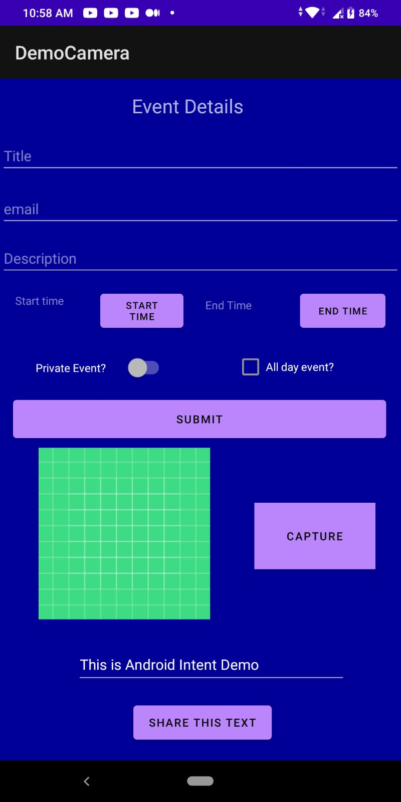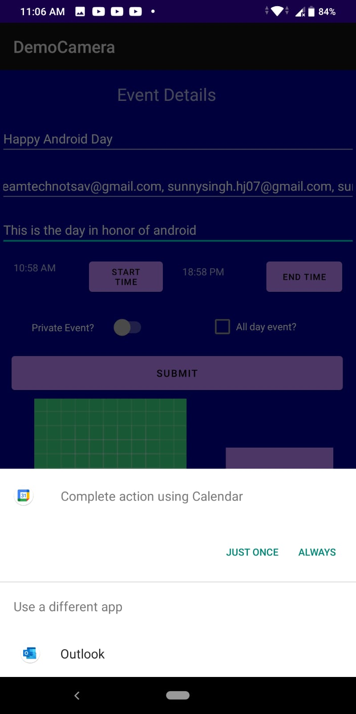

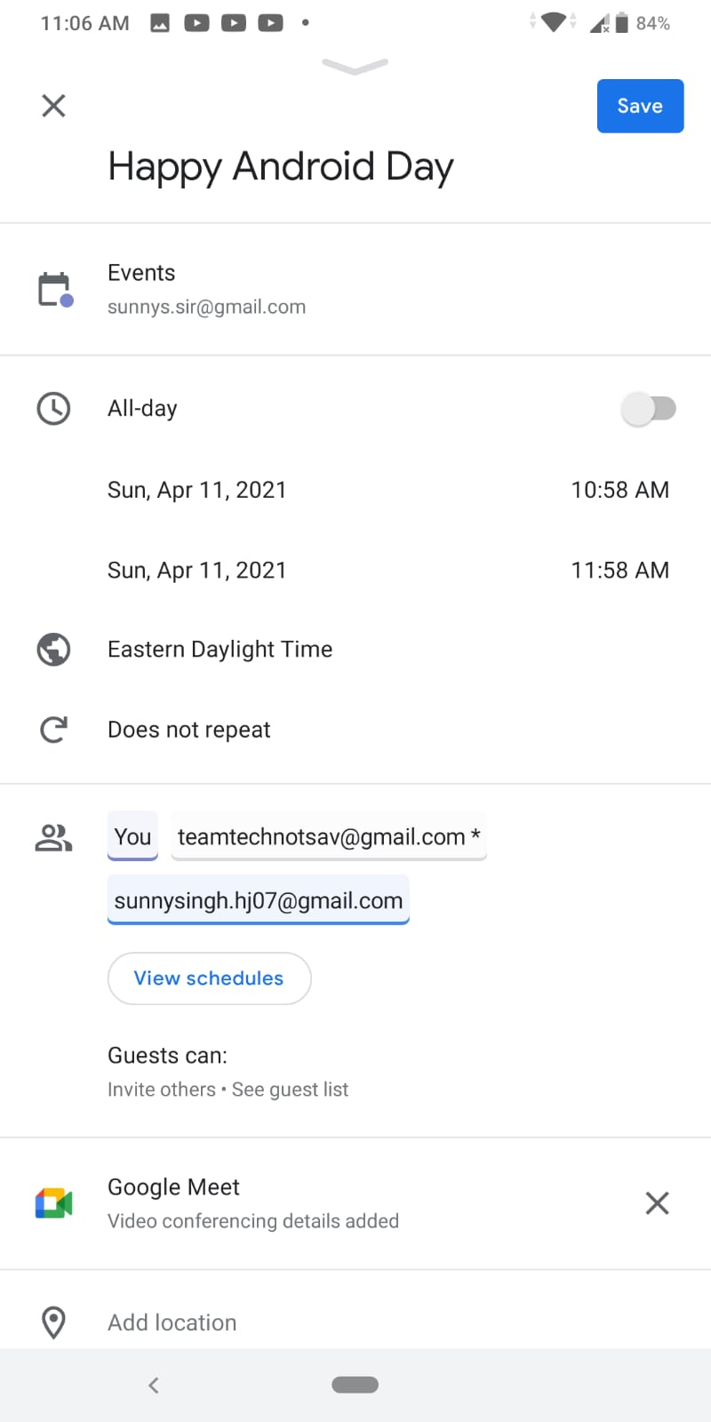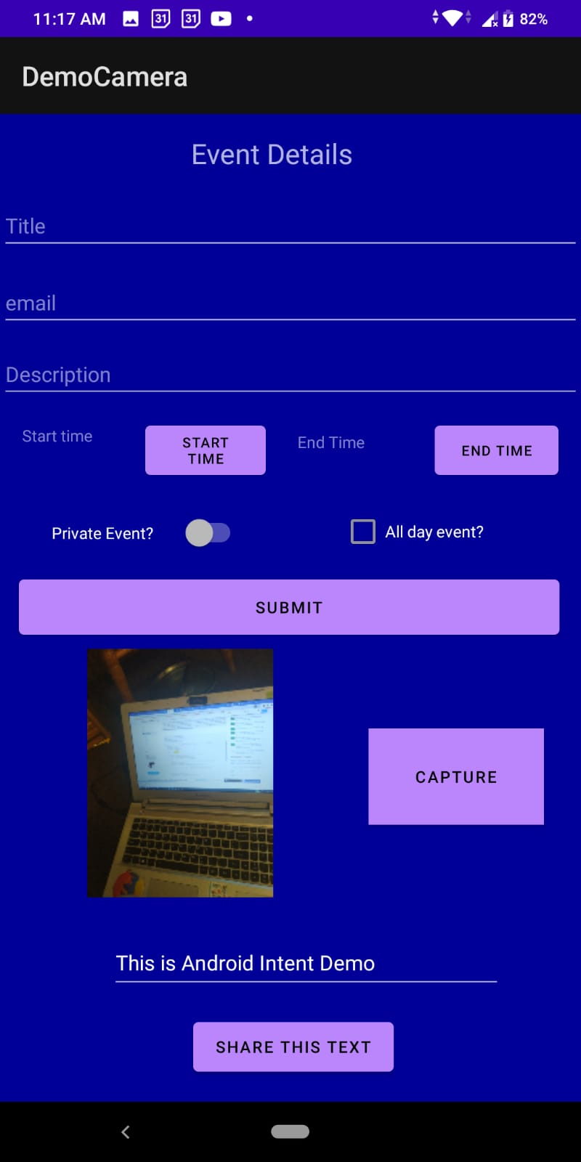

**Image store in storage**

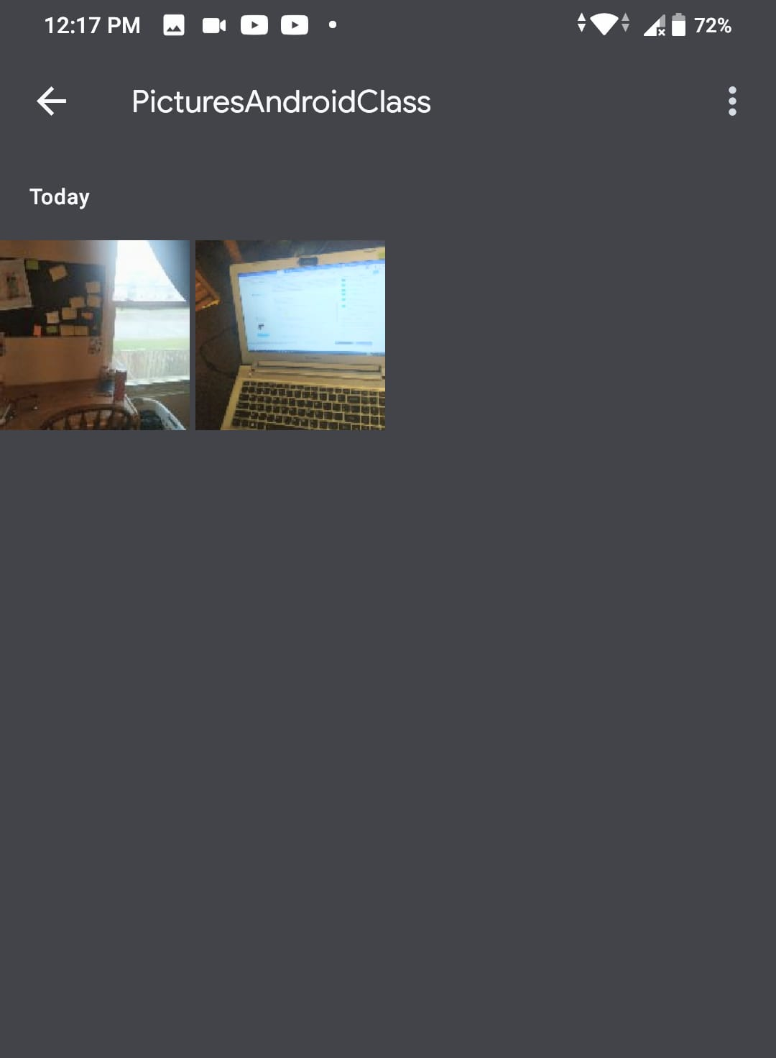

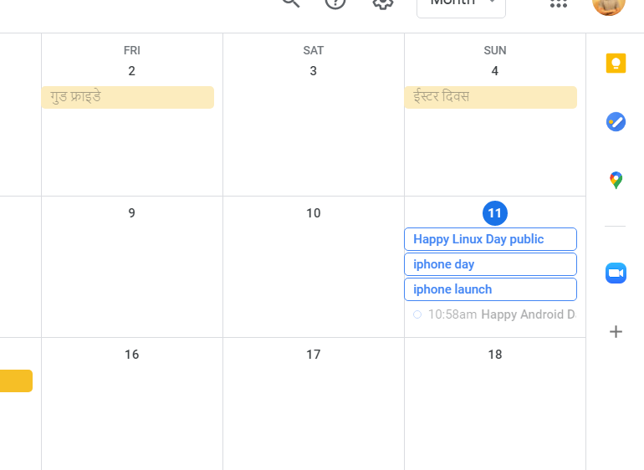

**If user switches to private event**

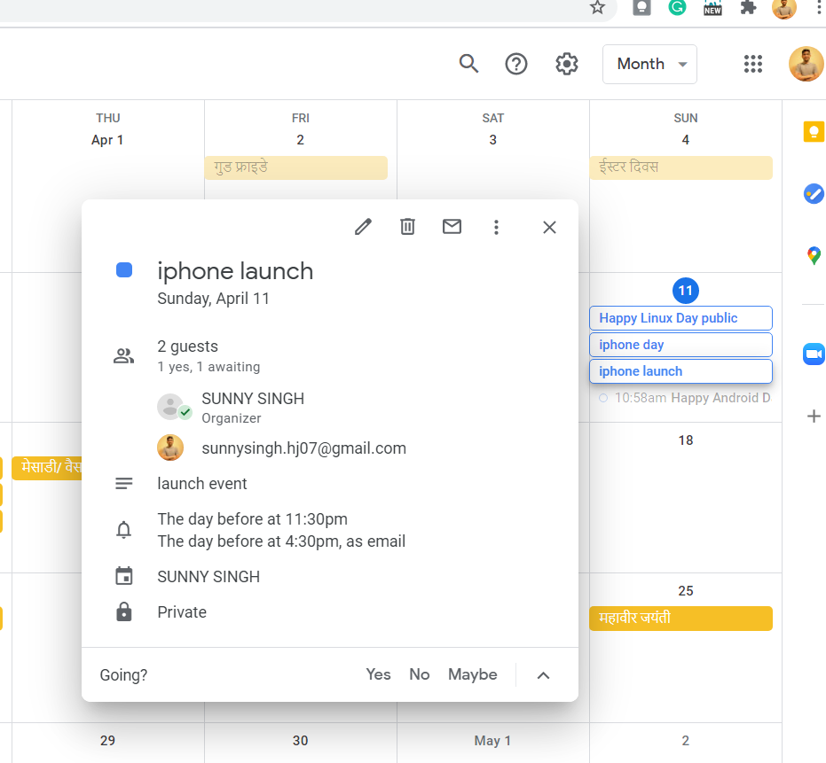

**If user does not enter values, toast message is displayed.**

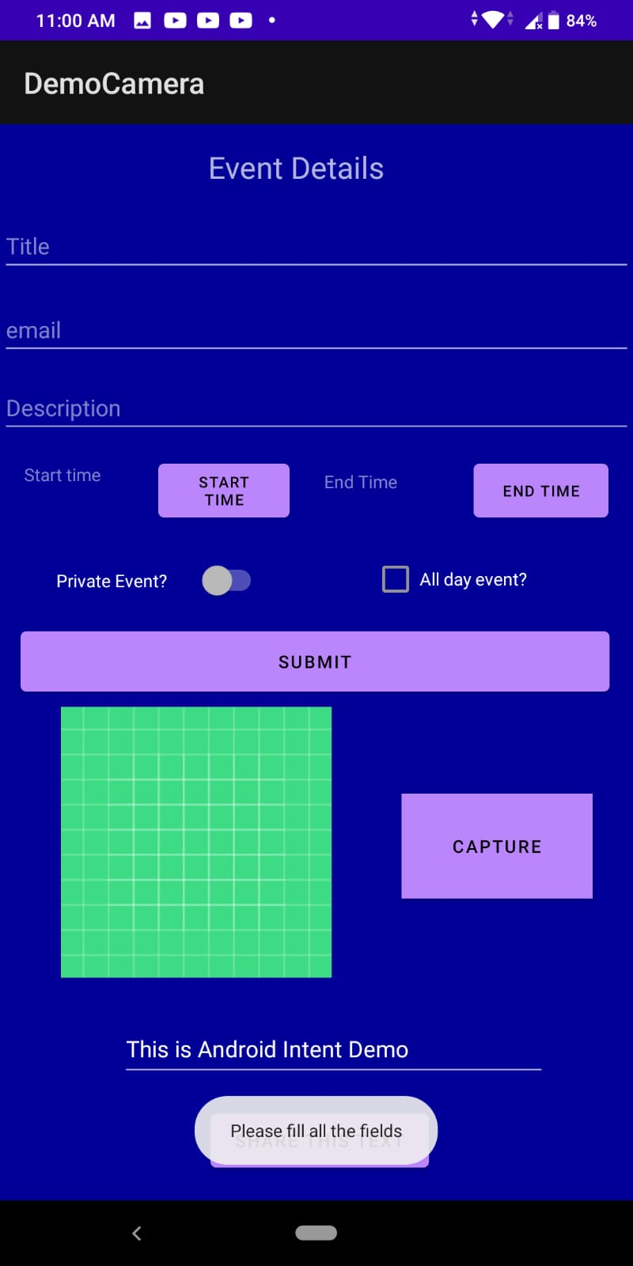

3rd Implicit Intent

